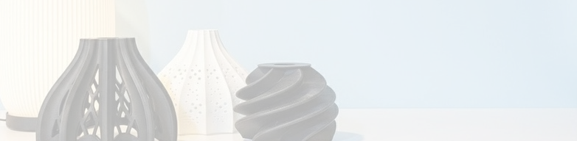
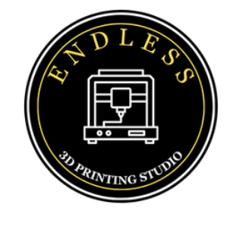
INVOICE

ENDLESS
3D PRINTING STUDIO

+91 9767973735

www.endless3dprinting.com




endless3dprintingstudio44@gmail.com

@3d_studio_be
Shop No.61, Jyotirmay Complex, Sector P-1, Cidco Town Centre, Seven Hills, Jalna Road Ch.Sambhajinagar (Aurangabad) Maharashtra-431003.

Invoice ID: {invoiceId}
Date: {date}
Customer: {customerName}

Sr.No | Description | Material | Quantity | Rate | Total
{#items}{srNo} | {description} | {material} | {quantity} | {rate} | {total}{/items}

Grand Total: Rs. {totalAmount}

Amount in Words: {amountInWords}

